Step 1: Data binding with string variables:

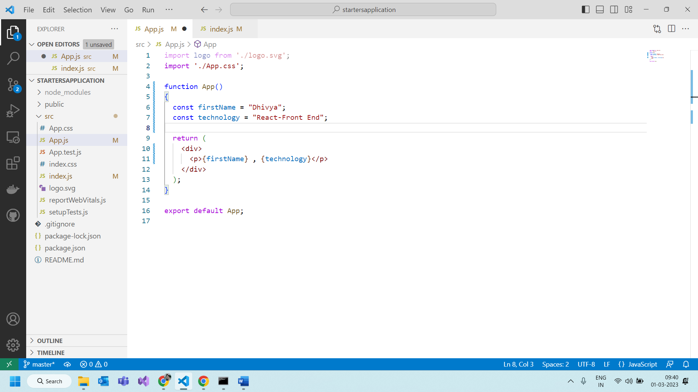

Trying to display the data based on condition

Condition false.

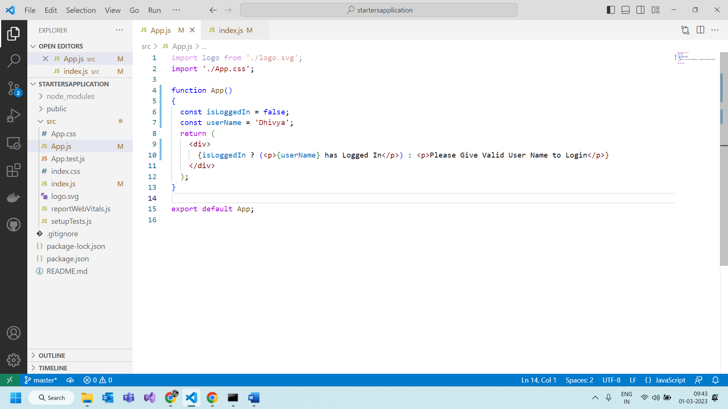

The output will be :

Condition is true:

Output:

Creating another functional component

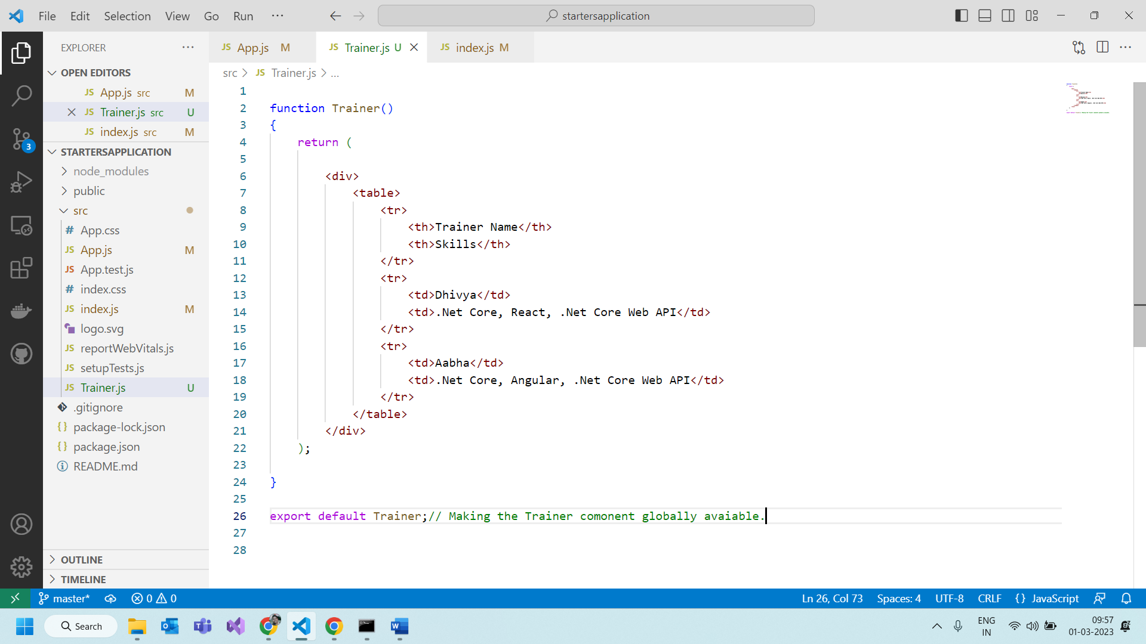

Function Component with input parameters:

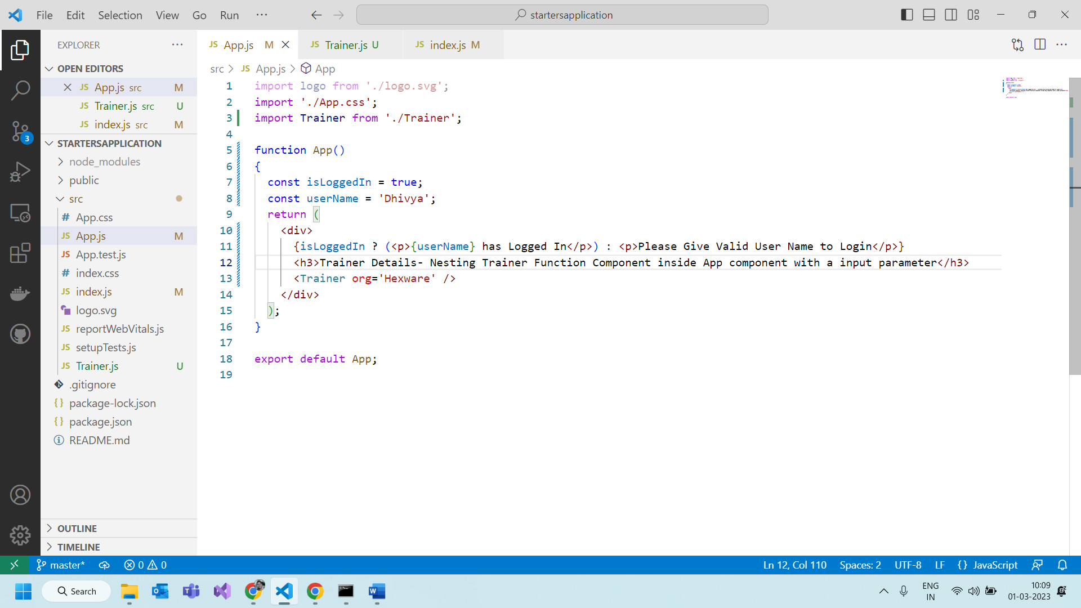

In trainer.js file:

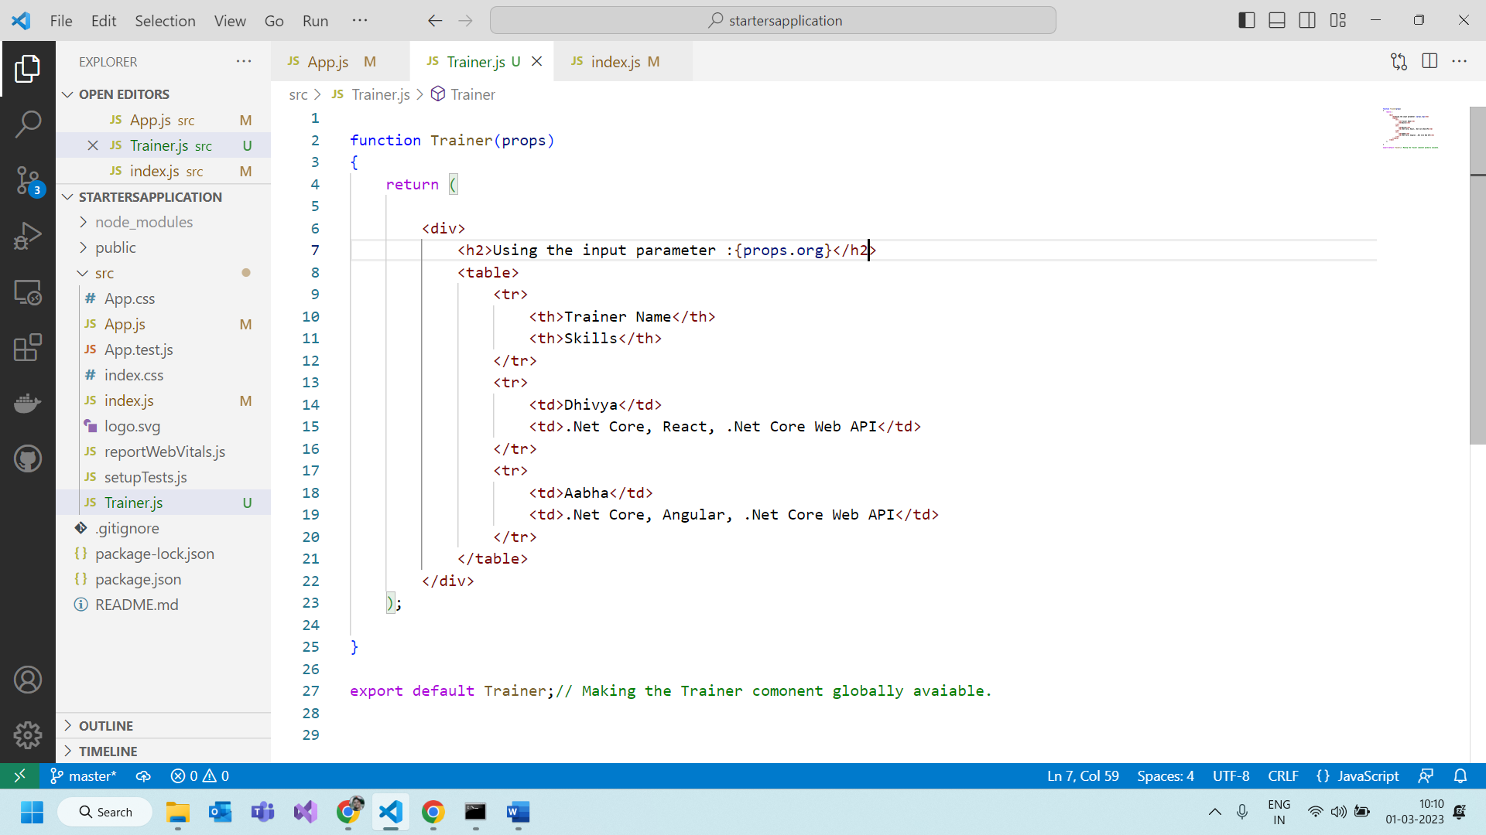

Creating function using Arrow functions

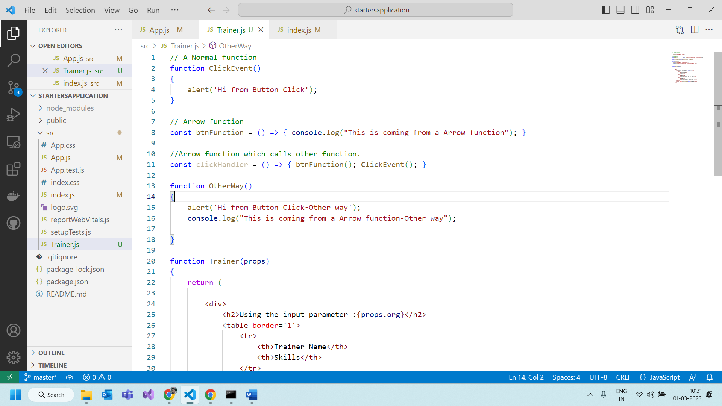

Event binding in react

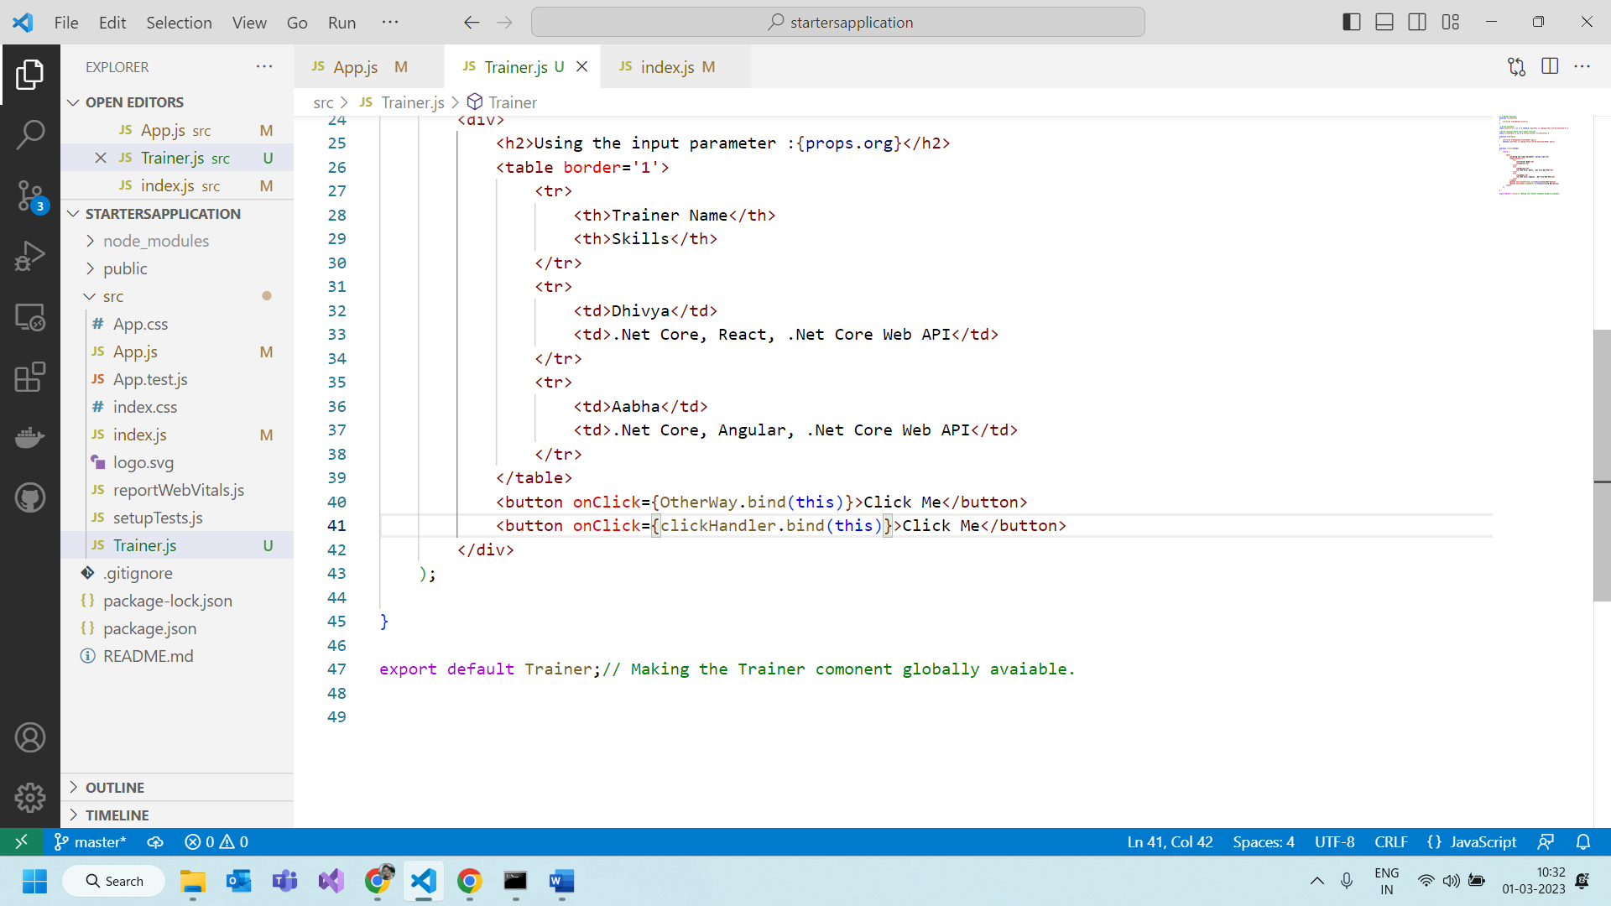

Passing arrays to the function component from parent component

In the App.js

Using a complex array and printing it

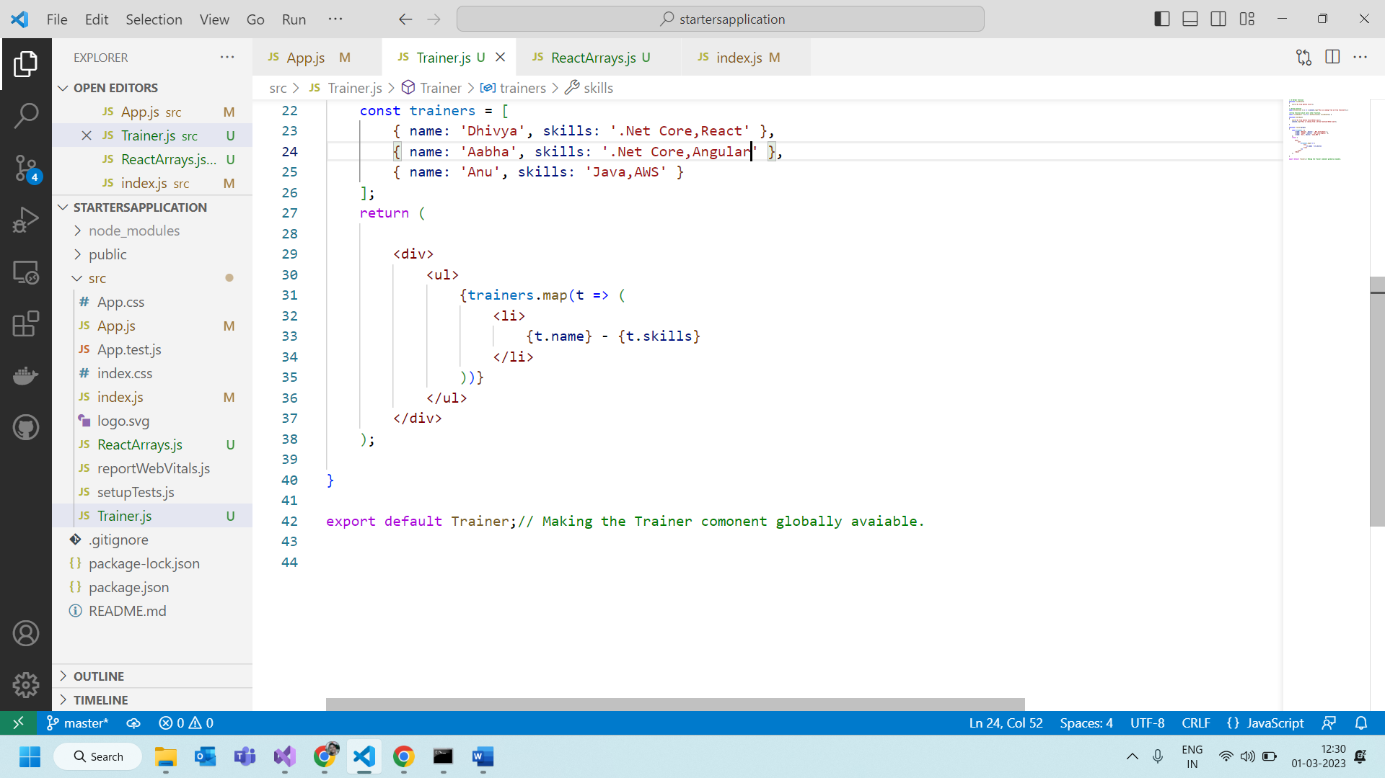

Class Component:

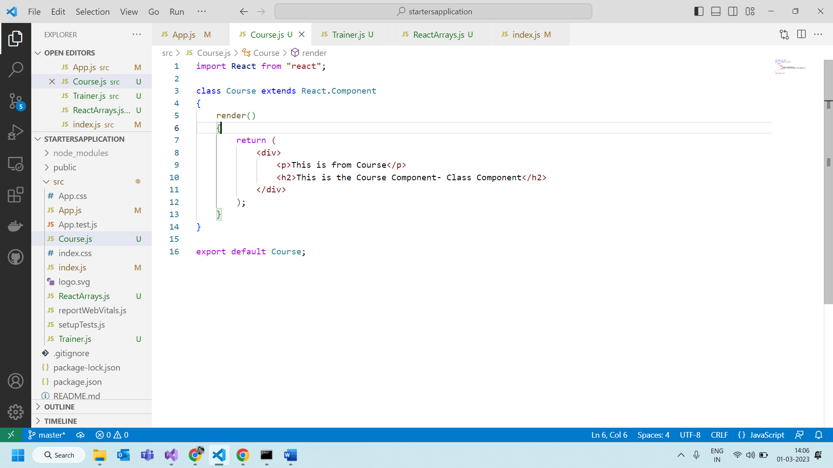

Class with properties and initialized using the constructor with this.state.

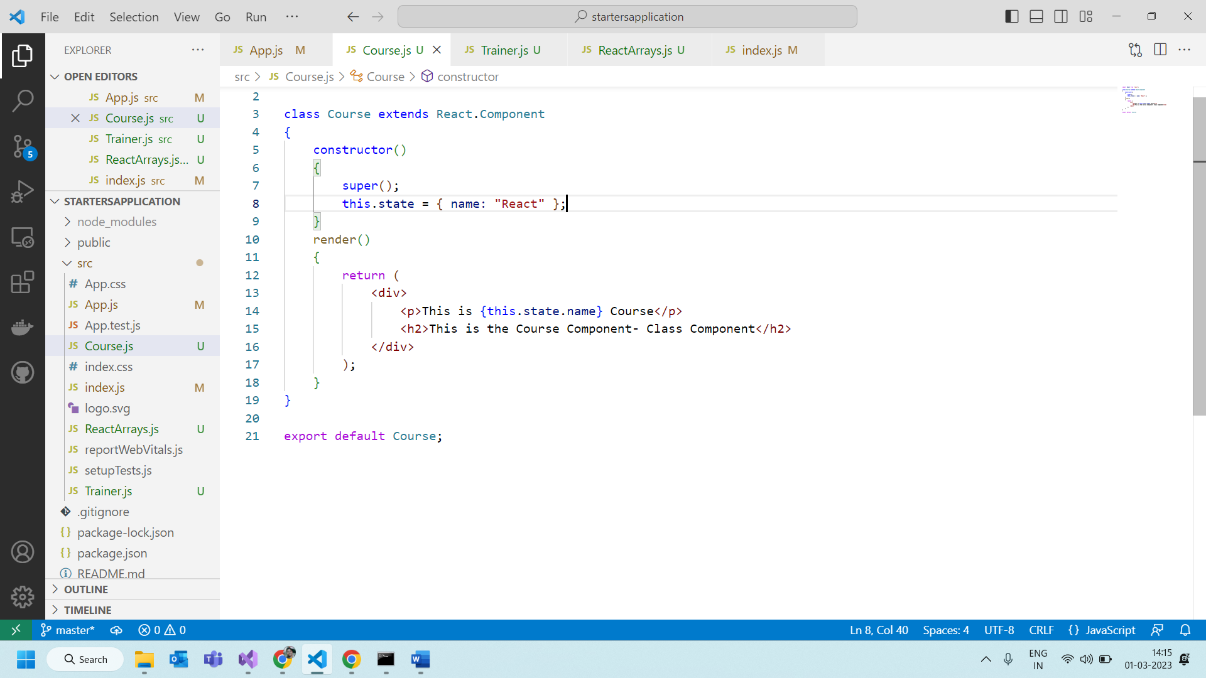

Managing the component properties using the props

In the app.js

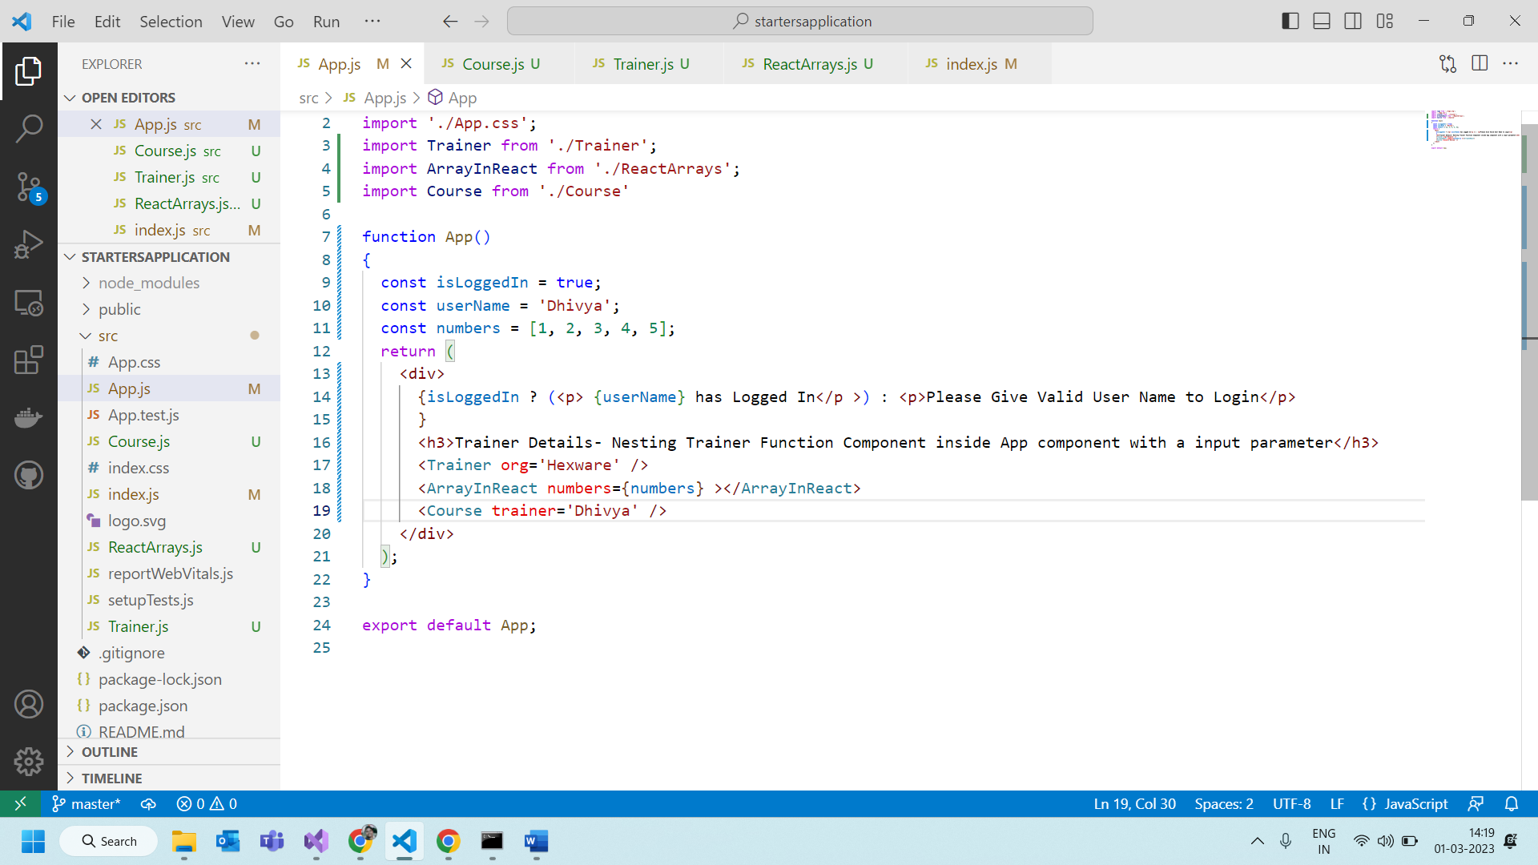

In the Course.js

Many properties in Course class component

React Hooks

Include the namespace import {useState} from ‘react’;

UseState for string update.

Use State for an object to update a single property.

**Need to update any array element.**

UseEffect Hook with simple example:

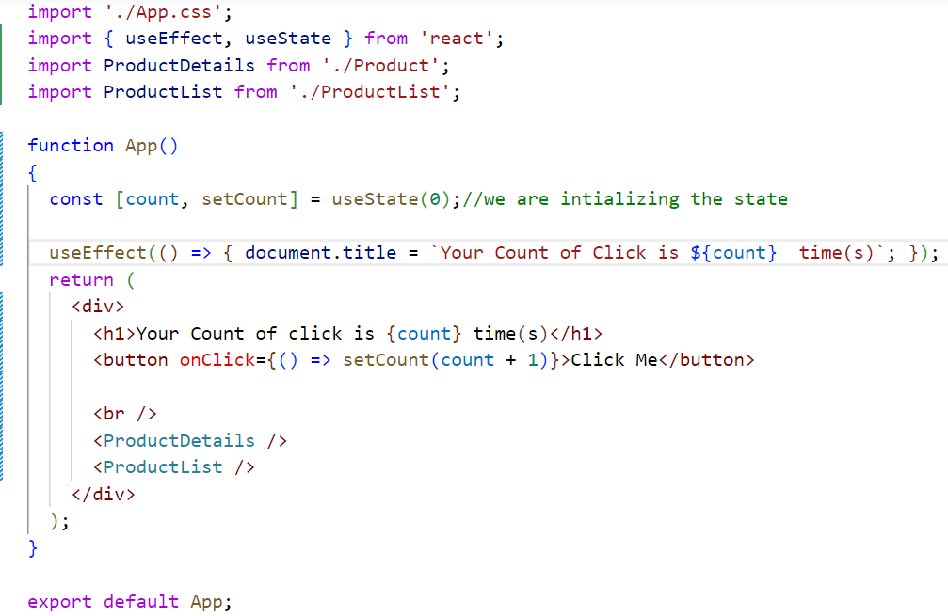

Calling the Web API

